CSA1411-COMPILER DESIGN

LAB EXPERIMENTS

NAME:- R KALAI AMUDHAN

REG NO:- 192511292

EXPERIMENT – 5:
AIM:-
Design a lexical Analyzer to find the number of whitespaces and newline characters.
CODE:-
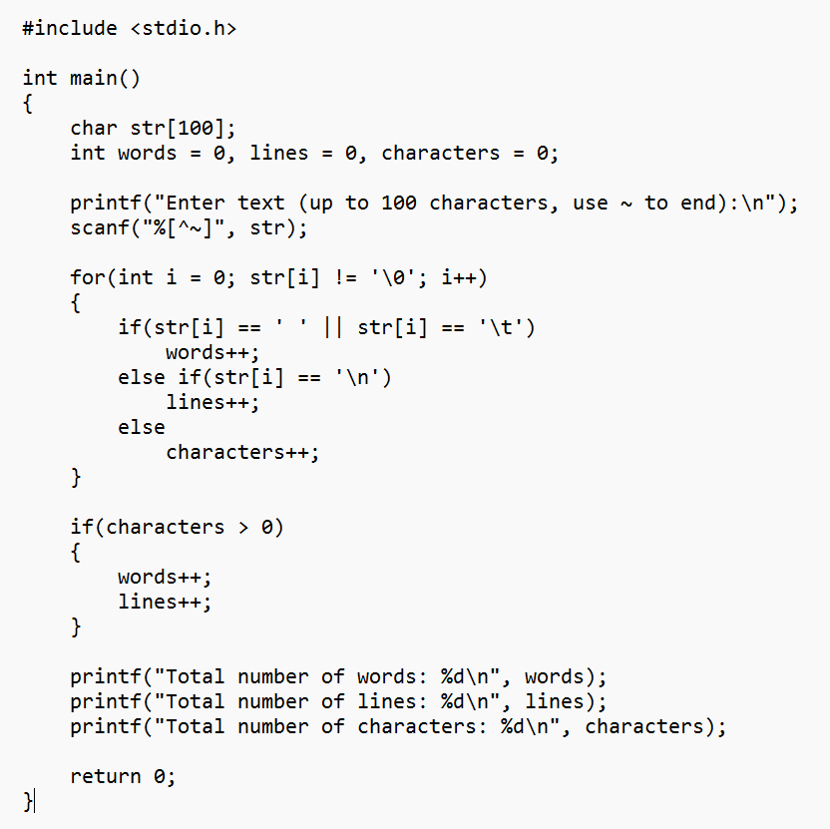
OUTPUT:-
